**PRACTICAL-7   
Demonstrate ES6 New Syntax and Test Browser Compatibility.**

1. Arrow Function :-

JS CODE:

const regularFunction = function (param1, param2) {

    return param1 + param2;

  };

  const arrowFunction = (param1, param2) => param1 + param2;

  const arrowFunctionMultiParams = (param1, param2, param3) => {

    return param1 + param2 + param3;

  };

  const noParameters = () => "Hello world!";

  console.log(regularFunction(1,2));

  console.log(arrowFunction(2,3));

  console.log(arrowFunctionMultiParams(1,2,3));

  console.log(noParameters());

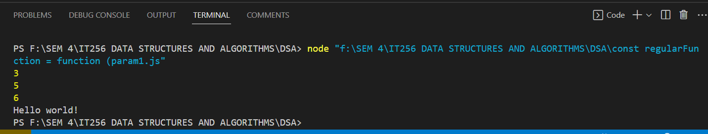

1. Destructuring :-

JS CODE:

let myNumbers = [1, 2, 3, 4];

let [firstNum, secondNum, thirdNum, fourthNum] = myNumbers;

console.log(firstNum);

console.log(secondNum);

console.log(thirdNum);

console.log(fourthNum);

let myObject = {

    name: 'John',

    age: 25,

    job: 'Software Engineer'

};

let {name, age, job} = myObject;

console.log(myObject.name);

console.log(age);

console.log(job); // Software Engineer

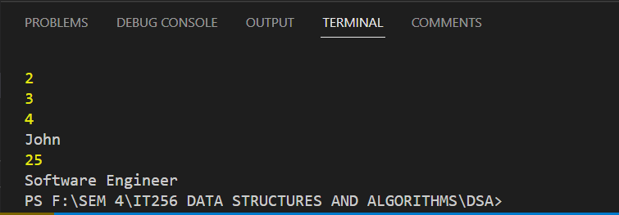

1. Spread vs Rest Operator :-

JS CODE:

const numbers = [1,2,3,4,5];

function add(a, b, c, d, e) {

  return a + b + c + d + e;

}

const sum = add(...numbers);

console.log(sum);

const numbers2 = [6,7,8,9,10];

const combinedNumbers = [...numbers, ...numbers2];

console.log(combinedNumbers);

